Autor’s full name ¹
NAME OF SPEACH

¹ Organization name

adress@domen.ru

The text of the short abstract of the report, up to 100 words. Indent before and after the text 12 pt. Orientation to the center, without indentation.
Material for publication should comply with conference thematic and present personal input of authors. The paper should meet the general requirements for scientific publications, contain an introduction, a brief description of materials and methods of research, a summary of the results, conclusions (without separating sections).
Articles submitted by students and secondary school students (pupils) should contain name of scientific leader.
Article volume is 4-5 pages. Portrait orientation; paragraph indentation of 1 cm; Single line spacing; Editor - Microsoft Office Word; Font - Times New Roman. Page numbers are not set, the headers and footers are not used.
References in brackets: number in the reference list and the page number, for example, [1, p.10], [2] in order of appearance in the text. Footnotes are not allowed. References should be done according to the GOST R 7.0.5 2008 «Bibliographic reference» (including electronic resource references).
The formulas should be included in the text of the report with the built-in formula editor MS Word, for example (1):

$\sum_{i=1}^{n}{u_{i}}$ (1)
Pictures (photos) and tables should be inserted into the text, numbered and titled (table 1, pic.1). In the text, references to the cited articles and figures are mandatory.

Table 1. Table in the text of article example
Size | … | … | …

10
You may use size 11 or 10 in the table if it is necessary.
Figures should be inserted in the text, interval before the figure 6 pt, interval after the caption 6 pt

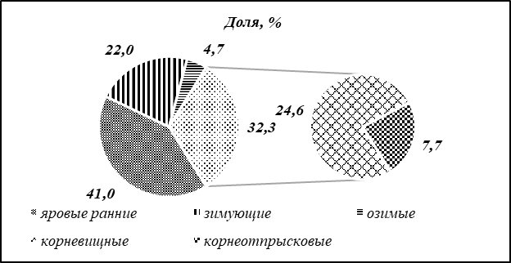

Fig. 1. Example of picture in the text of article
When inserting pictures, keep in mind that printing the collection is possible in black and white. In particular, for diagrams it is recommended to use shading instead of color filling.
Acknowledgements should be placed at the end of the article, without indentation, font 11, spacing 6 pt..

References
- Author. Title. Date line
- Автор. Article title. // name of periodical. Date line. – p. Number
- Name of electronic resource [Electronic resource]. Available at: http//… (access date)

